## COMP7810 Group Project

##### Microsoft World Wide Importer

**Problem statement definition**

We analyzed primarily a wholesale novelty goods importer and distributor operating out of the San Francisco Bay Area, selling products to retail customers across the United States. Each region has its own characteristics and markets. We analyze data from each of their regions to make recommendations on how companies can increase sales.

**Data exploration analysis & Data pre-processing**

WWI uses SQL Server Reporting Services to generate operational reports from the WideWorld database, and they also need to perform analysis on their data, and they need to generate strategic reports. WWI has created a dimensional data model in the database WideWorld World SDW. This database is populated by the Integration Services package.

SQL Server Analysis Services is used to create analytical data models from data in dimensional data models. SQL Server Reporting Services is used to generate strategic reports directly from the dimensional data model as well as from the analysis model. Power BI is used to create dashboards from the same data. We need to do data analytics on top of their data to help them grow their business.

**Descriptive analytics, key finding and discussion**

We analyzed primarily a wholesale novelty goods importer and distributor operating out of the San Francisco Bay Area, selling products to retail customers across the United States. Each region has its own characteristics and markets. This zoning can help sales teams better understand their target market and how to implement sales strategies in different regions. Outer areas may refer to remote or hard-to-reach areas, while other areas are divided according to factors such as geographical location, population density, level of economic development, etc.



*Fig.1 Sales Territory*

The dashboard provides users with a multi-dimensional view of the data through the combination of left and right sides. The chart on the left provides overall sales data by state, with different shades of color representing how much of the total was sold, while the chart on the right shows sales in specific cities based on user selection. This interactive design can help users gain a deeper understanding of sales and make more targeted analysis and decisions when needed. Texas, California and Pennsylvania are the top three states in terms of total sales, according to the distribution map of U.S. Sales.



*Fig. 2 dashboard of sales data by state and sales data by city*



*Fig. 3 Choose Texas and show the specific data*

Looking at the comparison chart of Sales by Product alone, the top five sales are consumptive logistics transportation items, including air buffers and different kinds of bubble film. The logistics and packaging industry is a key link in the circulation of all kinds of goods, so there is a constant demand for efficient packaging and protective materials. Air buffering and anti-static bubble film are favored because they provide an effective packaging solution. The bottom five are logistics transport items and fragile novelty items in the tool category. The market audience for novelty items may be relatively small and may result in lower sales. In view of the phenomenon of low sales volume of logistics transportation tools, the company can consider product innovation, functional improvement and other ways to enhance the attractiveness of products. In response to low sales of novelty items, companies can incentivize consumers to buy novelty products through time-limited promotions, discounts, or giveaways.



*Fig. 4 Sales by Product for top 5 and bottom 5*

From the perspective of Sales by State, Texas is one of the states with the largest population and economic volume in the United States, and its huge market size provides more opportunities for sales. Second, Texas has a diverse economic structure, including energy, technology, manufacturing and other sectors, which may have contributed to the increase in total sales. In Pennsylvania, California, and New York, factors such as economic development, population density, and industrial structure may also have a positive impact on total sales growth. California and Pennsylvania are located in important geographical locations in the United States and have developed transportation and logistics networks. This may be what makes these states the centers of distribution for products, allowing them to move quickly from where they are made to consumers.



*Fig. 5 Sales are ranked from highest to lowest*

From the combination of sales by state and sales by product, we can find that the sales volume of products in Texas has always been in the top three. Texas has a large consumer market, and its diverse economic structure means that there are a variety of consumer needs, providing a wide range of products to sell. No matter what the product, you can get more optimistic sales. It is wise for the company to continue to strengthen its focus and investment in the Texas market to further strengthen the company's market position in the region and explore more growth opportunities.



*Fig. 6 Choose the product air cushion machine(top 1) and observe the different of sales in each state*



*Fig. 7 Choose the product 32mm Double sided bubble wrap 50m(bottom 1) and observe the different of sales in each state*

Year by year, sales are gradually increasing. On a quarterly basis, sales in the four quarters did not show a gradual growth trend, but a fluctuating rise. The reason may be that sales in some industries are affected by seasonal factors, such as retail industry sales usually increase during the holiday season.



*Fig. 8 Time-sales chart*

According to the year observation, the overall sales volume shows a gradual growth trend. But in the second quarter of 2016, total sales fell too far. The overall number of sales is gradually increasing, which is a positive sign that the company's business is gradually expanding. However, the occurrence of a decline in total sales in the second quarter of 2016 May require further analysis. It could be the actions of competitors or macroeconomic factors or supply chain issues that occurred during that period that led to a drop in sales. The company can flexibly adjust its supply chain and inventory management strategies according to changes in the market environment to cope with fluctuations in market demand.



*Fig. 9 Time-quantity chart*

Proportions and Percentages 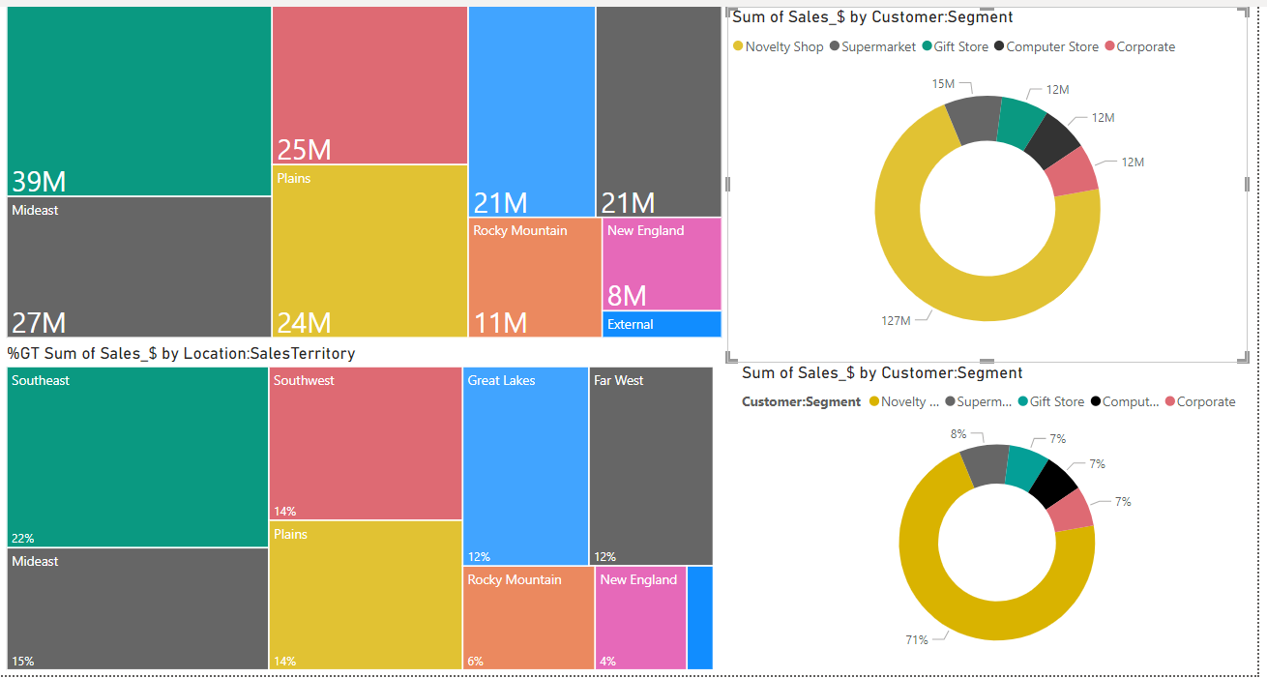

*Fig.10 TreeMaps(Left) and donutcharts(right)*

An analysis was conducted on the relationship between total sales across geographic regions and customer segmentation, visualized through a treemap and a donut chart.

The treemap provides a colorful and clear representation of the sum of sales distributed across various sales territories in the USA. Each rectangle represents a sales territory, with the size of the rectangle proportional to the total sales volume in that territory and the color indicating a specific region. It is divided into nine colored blocks, representing eight regions plus one external. Adjacent to the treemap is a donut chart displaying the total sales and the percentage breakdown of sales by customer segment, including segments such as Novelty Shops, Supermarkets, Gift Stores, Computer Stores, and Corporate Sales.

The diagram overview reveals that the top three regions in terms of total sales volume are arranged in descending order from left to right: Southeast, Mideast, and Southwest, with sales of $39 million, $27 million, and $25 million respectively. These three regions contribute a noteworthy $91 million to the total sales, accounting for 51%. The high sales in these regions benefit from factors such as high population density, rapid economic growth, tourism hotspots, and a culture of gift-giving. However, the bottom three regions, arranged in ascending order from left to right—New England, Rocky Mountains, and Great Lakes or Far West—sum to $40 million in total sales.

From a customer segmentation perspective, Novelty Shops are the major contributors, accounting for an impressive 71% of the sales. The percentage of total sales from Novelty Shops is the highest in each region. Their sales performance is heavily dependent on competitive marketing strategies, high product variety, unique product offerings, strategic shop locations, and tourism hotspots, compared to other customer segments.

Supermarkets contribute 8% of the total sales, ranking as the second top segment. Notably, the Mideast region ranks fifth among all regions. The sales performance is hampered by ineffective promotional strategies for supermarket retail channels. We suggest that the company optimize its marketing campaign to increase market penetration across different channels, thereby raising customer awareness of the products available in local supermarkets. Furthermore, the company should collaborate with supermarkets to offer attractive sales promotions to achieve sales targets.

From the perspective of the ‘Corporate’ segment, the bottom three regions are New England, Far West, and Southeast. Among all regions in the ‘Corporate’ segment, the company acquired 9% of corporate customers in the Southeast region, contributing only $1 million. Therefore, we suggest improvements in sales strategies, including more frequent client visits and participation in local exhibitions to acquire new corporate clients in this region.

The sales performance of the Plains region is robust, placing in the top three positions in the segments of Gift Stores, Corporate, and Supermarkets among all regions. It is recommended that the company execute a market penetration strategy by offering more resources to support sales growth in the region.

Sales distribution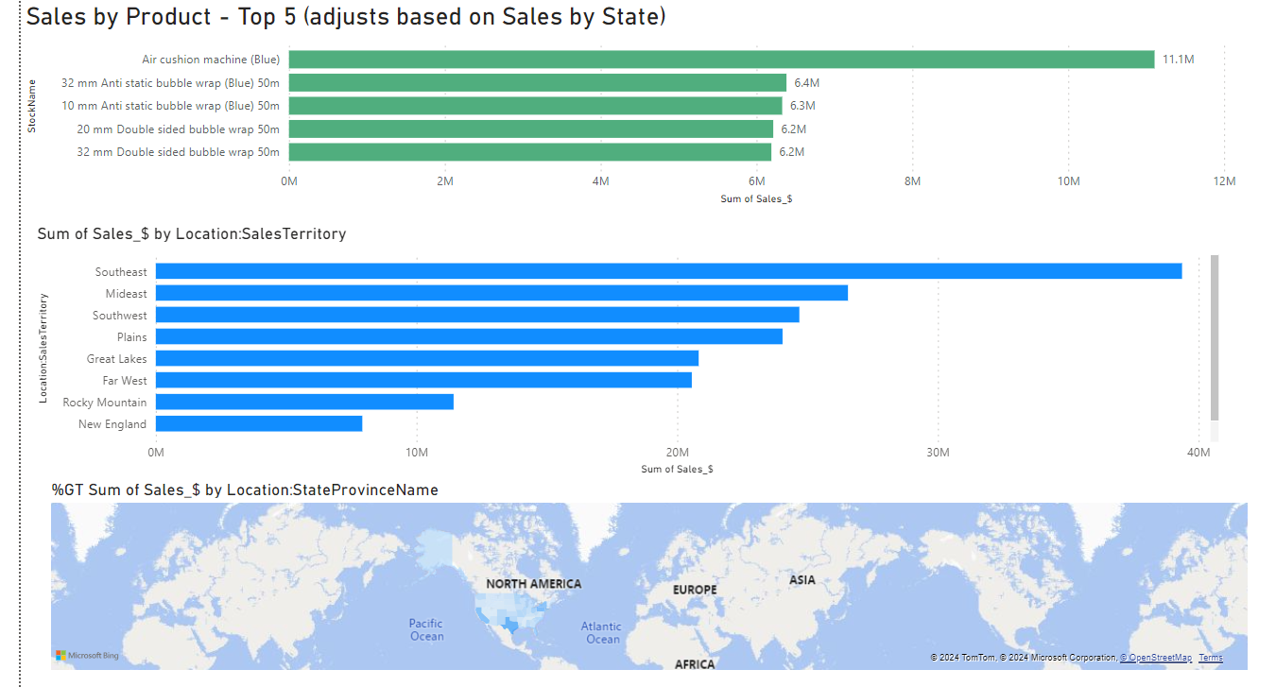

*Fig.11 Bar charts(above and middle) and Map(bottom)*

The top five products in total sales are consumptive packaging machines and materials, including air cushion machines and bubble wrap in various sizes. These products have the lowest total sales in two regions: New England, followed by the Rocky Mountains. Notably, Connecticut and New Hampshire in New England, along with Utah in the Rocky Mountains, rank as the bottom three states in total sales. The demand for air cushion machines and bubble wrap in these areas might be low due to the availability of alternatives or a lack of awareness. The marketing strategies employed in these regions have not been as effective, or these areas have received less focus from the sales team. It is suggested that the company allocate resources to these states to implement an effective promotional strategy for air cushion machines.

Product Sales Trend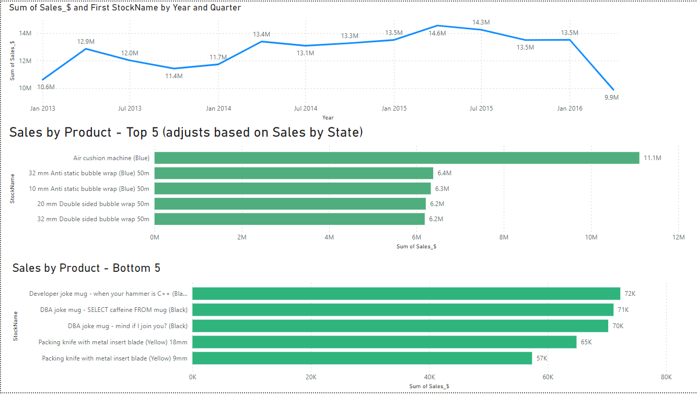

*Fig.12 Line graph and bar charts*

The observation of the total trend for the top five best-selling products from Q2 of 2013 to Q1 of 2016 indicates a seasonal pattern, with sales peaking around the middle of each year. This may be due to increased consumer activity during that period. We suggest that the company review its inventory levels in warehouses and coordinate purchases with suppliers to meet the increased market demand.

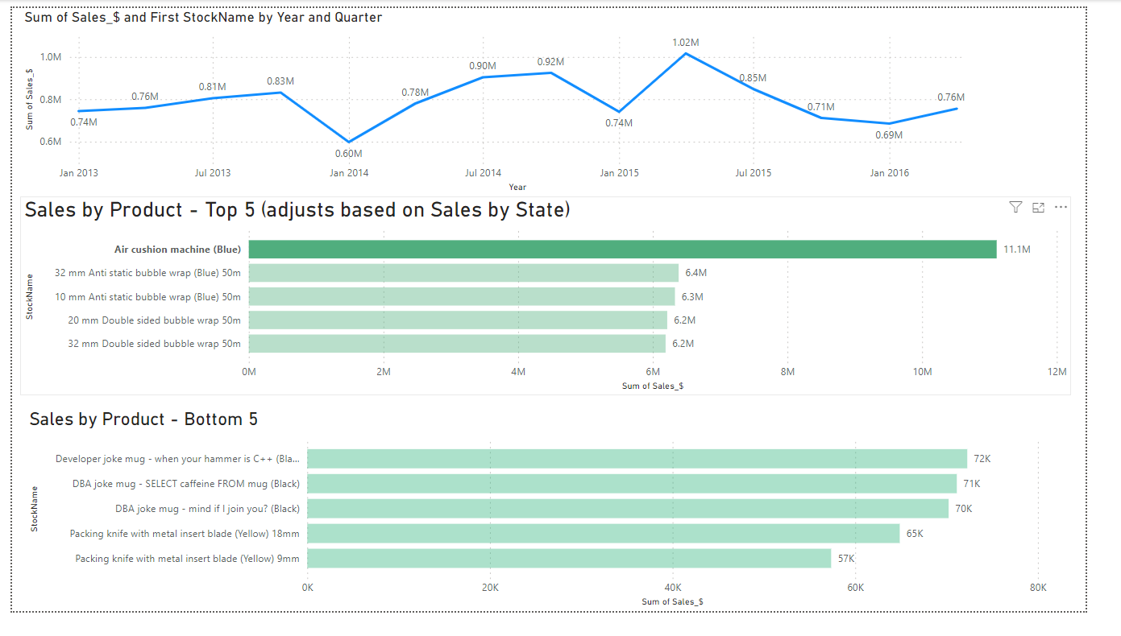

*Fig.12 Line graph and bar charts for top 1- product*

Here is the sales trend of our top-selling product. From the timeline, we can observe that the appearance of valleys adheres to the seasonal rule. At the beginning of each year, there is always a decrease in the sales of the previous year's Q4, followed by a steady increase to a peak. This sales trend may be influenced by holiday effects. Every Q4 features major holidays such as Christmas and Thanksgiving. For Q2, we have the Easter holiday. Before these holidays, people often purchase large amounts of goods as gifts, which also increases the demand for packaging. Therefore, we typically see a peak in Q2 or soon after.

From Q2 of 2015, the bottom five products show the weakest performance, indicating a trend of decreasing sales into the future. Products listed in the bottom five, such as the "Developer Joke Mug" and various "DBA Joke Mugs," have significantly lower sales, suggesting that they may be niche items or not well aligned with the target market’s interests. We suggest that management consider rebranding or discontinuing the product.

Conclusion

Through data analysis on sales performance, the key findings and results can bring stakeholders and the management in the company valuable insights and turn them into data-driven decisions to improve its overall sales and market position.